Discussion Questions  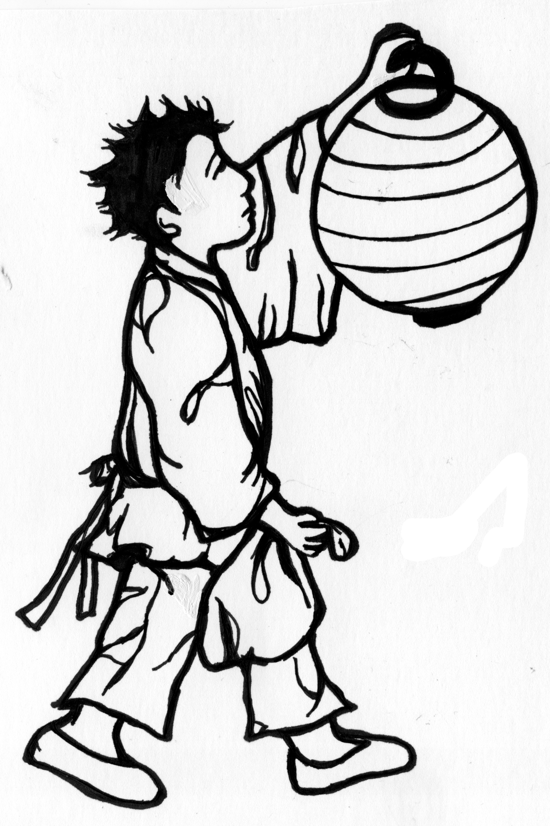  Starry River of the Sky  by Grace Lin  Name______________________  Room ________________ | Chapter 1  - What does the stowaway, Rendi, realize is missing? What specific details help him draw this conclusion? P. 1  - Why did the merchant tell the innkeeper he should buy a gang of wine? P. 2-3  - Why didn’t the innkeeper want to buy a gang of wine? How much wine did the innkeeper need? P.3  - How did the merchant react to Rendi? P 4-6
Chapter 2  - What did the inn keeper want to use Rendi for? How did Rendi feel about his new job? P. 8  - What is Master Chao’s daughter’s name? What symbol did he write on her forehead? Why? P. 9-10  - How do Peiyi and Rendi feel about each other? Explain your answer using evidence from the book. P. 10-12 | Chapter 3  - Describe the “Stone Pancake.” P. 13  - What did the Village of Clear Sky used to be called? How did Rendi react to the small village and inn? P. 13  - Why did Peiyi’s great-grandfather want to move the mountain? P. 15  - How did Peiyi’s great-grandfather work to move the mountain? P. 16  - How did the mountain eventually move? P. 17

Chapter 4  Rendi seems to be more than a simple chore boy. What clues help you infer this? P. 20  What type of relationship do you think Rendi and Peiyi will have? Explain your reasoning. | Chapter 5  Peiyi and Rendi are intrigued by their new guest. What is she like? What impression does she leave on Peiyi and Rendi? P. 25  What happened when six suns appeared in the sky? P. 27  In “The Story of the Six Suns,” who do you think shows heroism? Is it WangYi or his wife? Why do you think this?  Why is there only one sun now? P. 29
Chapter 6  Who did Master Chao fight with every day? P. 31  How did MeiLan and Jiming become friends? P. 37-38  Why is the jade bracelet so special to her? What does MeiLan say will not happen without her bracelet? P. 35-36  Why did Meilan and Peiyi become alarmed when Master Chao was calling out for Peiyi? P.39 | Chapter 7  What was the ironic thing about Widow Yan’s tofu? P. 40  Why was Rendi surprised by the way Madame Chang treated Mr. Shan?  What is the lesson behind “The Story of the Rooster’s Song?” Why does Madame Chang tell this story? P. 43-45

Chapter 8  Why is it difficult for Rendi to sleep at night? P. 47  How do the stories Madame Chang tell make Rendi feel?  P. 48  Why does Peiyi become angry with Rendi? What does she say to him that makes him think about leaving the inn?  P. 49 |  | Chapter 9  How does Rendi feel about the toad at first? How do his feelings change? What evidence from the story supports your answer? P. 53 -56  How did Madame Chang’s appearance help Rendi with the situation? P. 56
Chapter 10  How does seeing the Chao family’s shrine room help Rendi understand Peiyi better? |  | Chapter 11  Why was Rendi surprised by Madame Chang? P. 61  What was the deal Madame Chang made with Rendi? Do you think he will follow through? Why or Why not? p. 63  In “The Story of the Old Sage,” Tiwu is taught a valuable lesson. What lesson does he learn? Why does Madame Chang tell this story?
Chapter 12  Describe what happened to Rendi at the well. P. 73  How are Rendi’s actions and appearance similar to his father’s? How does this make Rendi feel? Use text evidence to support your response. P. 73-74 | Chapter 13  Why did Rendi avoid looking at Madame Chang?  P. 76-77  What are two reasons the magistrate is called “Magistrate Tiger?” p. 78-79  How did the magistrate’s children feel when they were throwing the rice in the air while their father played the qin? P. 81  In Rendi’s “Story of the Jumping Fish,” how does Magistrate Tiger trick Duke Zhe?
Chapter 14  Why did Madame Chang have sadness in her eyes? P.87  How did Madame Chang teach them to make light without wasting oil? P. 88  What did the whole town end up doing together in the night? P. 89-90  What could Rendi hear that others couldn't? Why?  P. 92 | Chapter 15  How did Mr. Shan interact with the toad? Why did he call it “Rabbit?” p. 95  Why did the Queen Mother of the Heavens give the pill of immortality to WangYi? P. 97  How did WangYi change after he was given the pill of immortality? P. 98  What did WangYi's wife do with the pill when she found it? P. 100  What happened to WangYi's wife when she swallowed the pill of immortality? P. 100-101  Who is the moon lady? What can she do? P 102-103

Chapter 16  1. What did Mr. Shan do to the half-moon well? 105  2. What did Mr. Shan tell Rendi not to do? 106  3. When Mr. Shan said, “Make sure you do as you say,” what was he referring to? 107  4. What did Rendi take out of his drawers? 108 | Chapter 17  1. How did the boy say he would figure out which man was the thief? 112  2. Why did Magistrate Tiger’s wife tell her children he was always angry? 113  3. What did the emperor give to Magistrate Tiger for answering his first question correctly? 115  4. Why did Jiming leave the village? 120
Chapter 18  1. Where did they have Master Chao and Widow Yan sit? 123  2. What did Master Chao and Widow Yan decide were delicious?126  3. What did Master Chao and Widow Yan decide to do with the snails? 128 | Chapter 19  1. Why does Peiyi say that Rendi can come home?129  2. What did Mr. Shan used to do that he doesn’t do anymore?131
Chapter 20  1. Where do superstitious guests always want rooms in the inn? Why? 136  2. What did the trader’s belt have hanging from it? 137  3. Who was the government official that came to the inn? 137 | Chapter 21  1. What was the custom the officials saw the villagers do? 139  2. Why did the villagers do the dog wedding? 139  3. Why did people throw dirt on the dragon figures? 140
Chapter 22  1. Why was Duke Zhe traveling? 143  2. Why was it impossible to destroy the White Tiger? 145  3. How did the white Man/Tiger save the child? 152  4. Who was the White tiger/man? 156 | Chapter 23  1. Why did Mr. Shan forget everything? 159  2. Describe Mr. Shan’s house. 161  3. What does the moon symbolize? 161

